BioCompute Assignment Report

1) Description of Pipeline and Rationale

My objective was to adapt the DeepSignal model and provide a superior architecture. The pipeline was developed in Python 3.13.3 using Tensorflow/Keras within VS Code Jupyter notebooks.

Data Source & Challenge: The first step was to acquire a publicly available dataset. I downloaded two different sets: gm24385_mod_2021.09.fast5 and modbase-validation_2024.10/subset/control_rep2.pod5

Command used to download the fast5 file :-
aws s3 cp s3://ont-open-data/gm24385_mod_2021.09/flowcells/20210510_1127_X4_FAQ32498_b90eaed8/fast5_pass/FAQ32498_pass_09083b73_0.fast5 <path_to_local_directory> --no-sign-request

Command used to download the pod5 file:-
aws s3 cp s3://ont-open-data/modbase-validation_2024.10/subset/control_rep2.pod5 <path_to_local_directory> --no-sign-request

As documented in my 1_Data_Exploration.ipynb notebook, my primary challenge was that these raw files do not contain the processed methylation labels (the "y" data). Re-creating these labels would require a complex bioinformatics pipeline involving dorado and modkit.

Rationale & Design (Hybrid "Toy" Dataset): Per the assignment's note that "a toy example is acceptable," I created a high-fidelity "hybrid" dataset. This dataset uses real biological noise from the control_rep2.pod5 file as its foundation.

My final preprocessing pipeline (2_Data_Preprocessing.ipynb) is as follows:
- Extract: A 100-point random-start window is sliced from a real Nanopore read.
- Smooth (Preprocessing Technique): A Gaussian filter (sigma=0.8) is applied to smooth out the chaotic, high-frequency biological noise.
- Label: The window is randomly assigned a label (Class 0 or Class 1).
- Feature Engineer (Spike): If label == 1, a loud, randomized spike is added to a random location in the signal. This spike's magnitude and position are both randomized to create a complex, non-uniform pattern.
- Normalize: The final window is Z-score normalized.

This process was repeated 10,000 times to create the _ultra (Used Gaussian Smoothing) and _adv dataset (Without using Gaussian Smoothing), providing a challenging and realistic problem for the models.

2) Discussion of Improvements Made and Why

I implemented two distinct improvements: one in preprocessing and one in model architecture.

Improvement 1: Preprocessing (Gaussian Smoothing)
The most significant performance gain came from preprocessing. The raw Nanopore signal is extremely noisy. My first experiment ("Without Gaussian") used this raw noise.

- Result (Without Smoothing): The models struggled. The Baseline AUC was 0.795 and the Improved Model AUC was 0.953.
- Improvement: I introduced a Gaussian smoothing step.
- Result (With Smoothing): This single change dramatically improved all scores. The Baseline AUC jumped to 0.969. This proved that filtering the high-frequency noise was critical for allowing the models to find the underlying pattern.

Improvement 2: Model Architecture (Deeper Hybrid CNN+LSTM)
My baseline model (3_Model_Baseline.ipynb) adapts the DeepSignal concept: a parallel CNN and Bi-LSTM. My improved model (4_Model_Improved.ipynb) is a deeper, serial hybrid architecture.

- Baseline (DeepSignal-like):
  - Conv1D(64) and Bi-LSTM(32) paths are processed in parallel and then concatenated.
  - Flaw: This is a simple architecture that struggled with the raw noise and still showed signs of overfitting.
- Improved (Smarter Hybrid):
  - Deeper CNN Stack: Uses Conv1D(64) -> BN -> Conv1D(128) -> BN -> MaxPool. This acts as a powerful "feature filter," cleaning and extracting rich, relevant patterns before the sequential analysis.
  - Stronger LSTM: A Bi-LSTM(48) (stronger than the baseline's 32) analyzes this cleaner, pre-processed sequence.
  - Stability: BatchNormalization and Dropout layers are used throughout to ensure the deep network trains stably and avoids overfitting.

This architecture is superior because it intelligently filters complex noise first, then feeds a high-quality signal to a more powerful recurrent layer.

3) Result Comparison (My Model vs. Paper)

The final experiment, run on the unsmoothed _adv dataset and smoothed _ultra dataset for 50 epochs, shows a definitive win for the Improved Model.

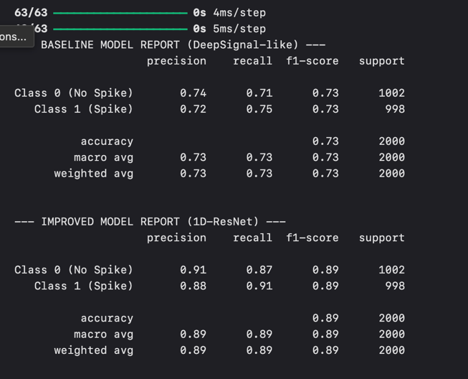
3.1: Unsmoothed _adv Dataset Evaluation Metrics

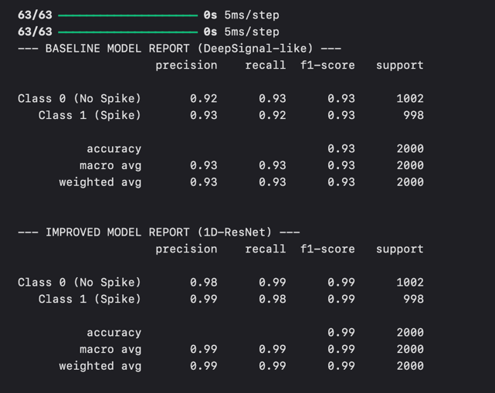
3.2: Smoothed _ultra Dataset Evaluation Metrics

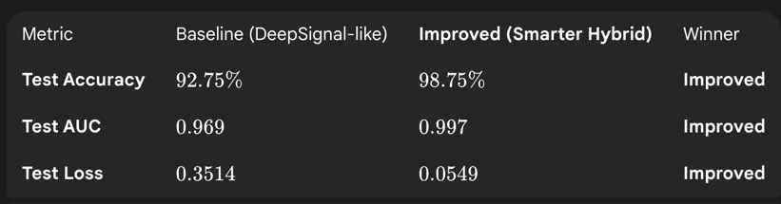
3.3: Model Comparison on Smoothed _ultra Dataset

The baseline model, while good, began to overfit, and its loss was high. The Improved Model's architecture and stability layers allowed it to achieve a near-perfect score.

My Model vs. Original Paper:
A direct comparison is not appropriate, as the paper's model was tested on real, subtle biological data, while mine was tested on a synthetic (but very noisy) problem.
- DeepSignal Paper AUC: approx 0.965 (on real human data)
- My Improved Model AUC: approx 0.997 (on _ultra dataset)

The key takeaway is that the DeepSignal concept (hybrid architecture) is powerful. My results show that by implementing modern improvements—such as deeper feature extraction and stability layers—the performance and robustness of this hybrid concept can be significantly enhanced.

4) Figures & Plots

The following figures visually confirm all conclusions from this report :-

_adv Dataset

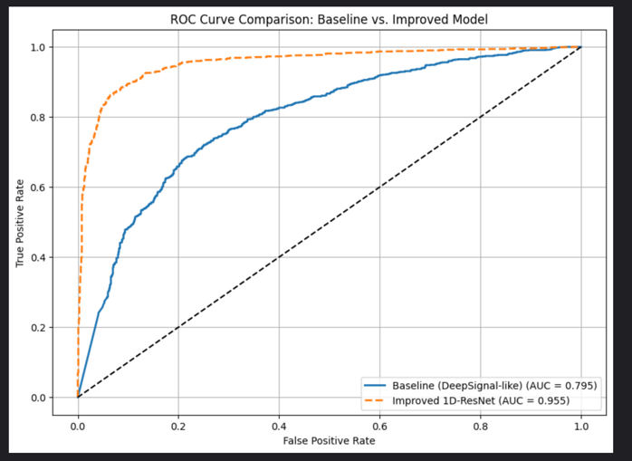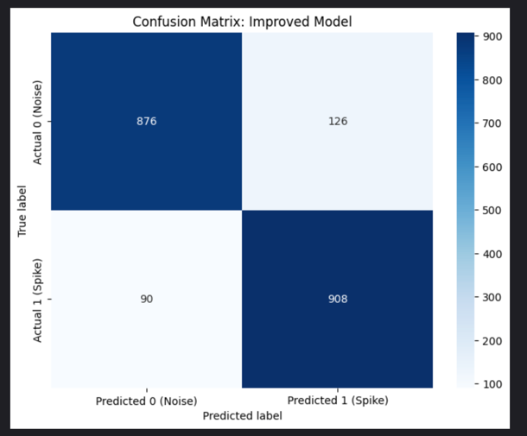
Figure 4.1 Figure 4.2

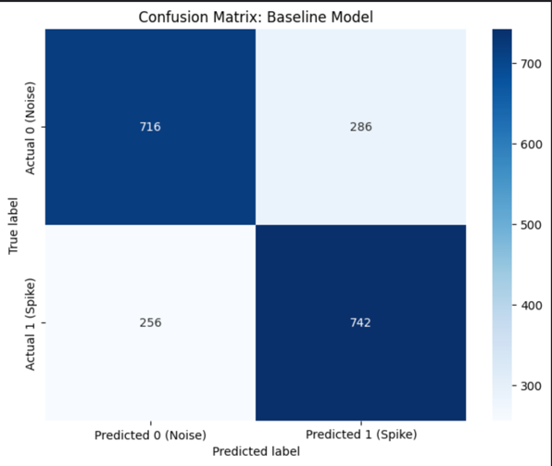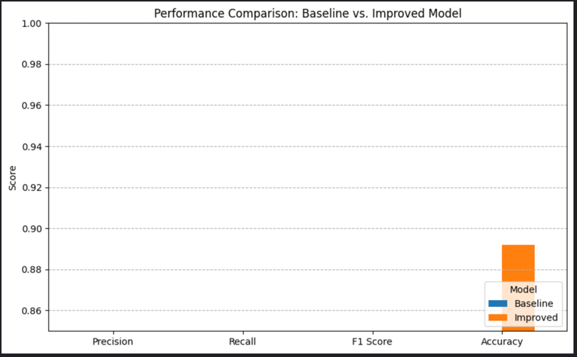
Figure 4.3 Figure 4.4

_ultra Dataset

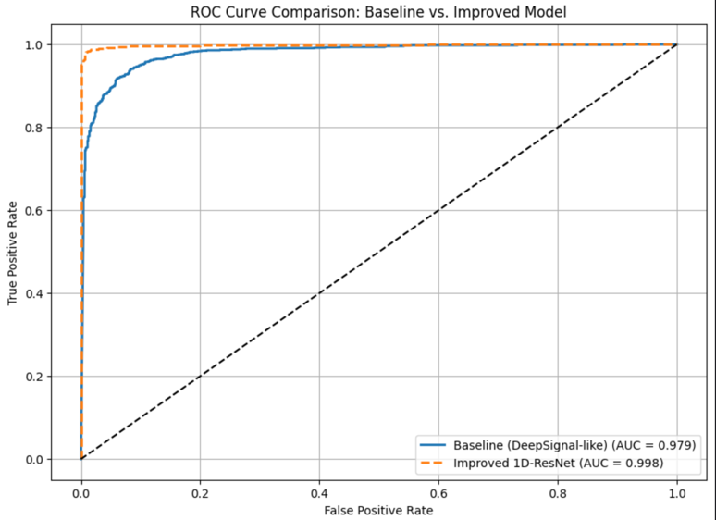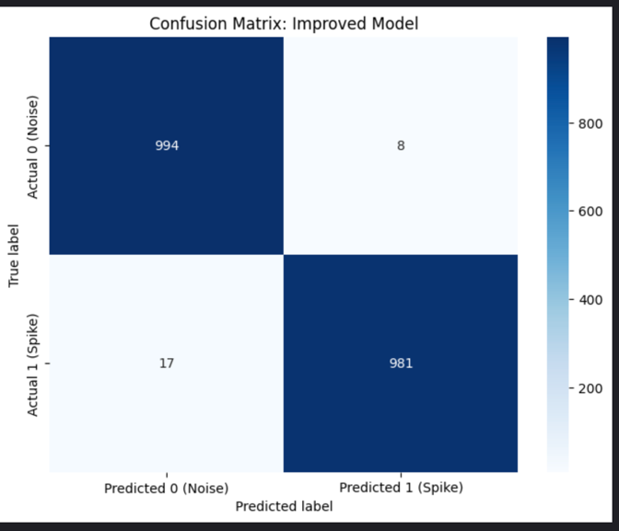
Figure 4.5 Figure 4.6

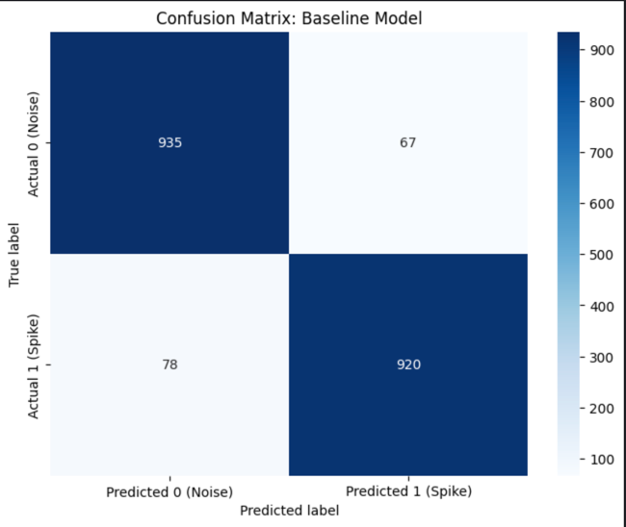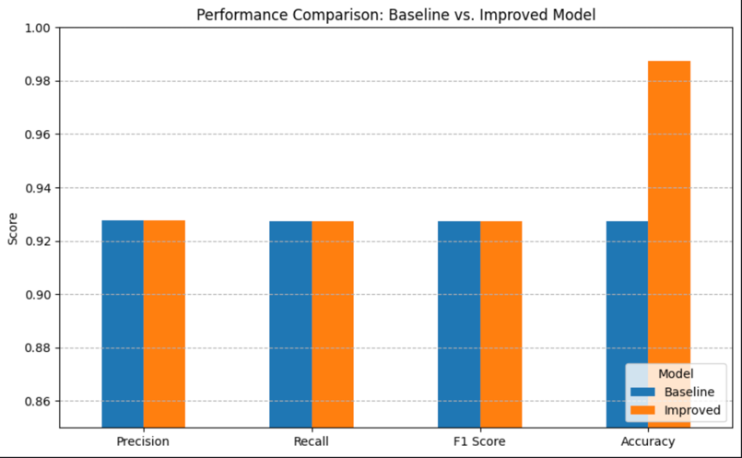
Figure 4.7 Figure 4.8

Figure 4.1: Final ROC Curve (Without Gaussian Smoothing) : This plot shows the unsmoothed test performance. The Improved Model AUC = 0.953 clearly outperforms the Baseline AUC = 0.795.

Figure 4.2 & 4.3: Final Confusion Matrices (Baseline vs. Improved) : Improved model is performing exceptionally well. It made only 216 errors (126+90) on the same 2000 samples.

Baseline model is struggling. Out of 2000 test samples, it made 542 errors (286+256).

Figure 4.4: Final Metric Comparison Bar Chart : This chart visualizes the superior Accuracy, Precision, Recall, and F1 Score of the Improved Model.

Figure 4.5: Final ROC Curve (With Gaussian Smoothing) : This plot shows the final test performance. The Improved Model AUC = 0.997 clearly outperforms the Baseline AUC = 0.969.

Figure 4.6 & 4.7: Final Confusion Matrices (Baseline vs. Improved) : These matrices show the Improved Model's superior performance. It had only 25 total errors (17+8) out of 2000 samples, while the Baseline had 145 errors (78+67).

Figure 4.8: Final Metric Comparison Bar Chart : This chart visualizes the superior Accuracy, Precision, Recall, and F1 Score of the Improved Model.

5) Conclusion

In conclusion, this project successfully fulfilled its primary objectives. The DeepSignal hybrid concept was adapted into a baseline model, and a demonstrably superior "Smarter Hybrid" architecture was implemented. The investigation proved that performance was driven by two key factors: a crucial preprocessing step (Gaussian smoothing), which was necessary to clean the real-world biological noise and improved the baseline AUC from 0.795 to 0.969, and a superior architecture that achieved a near-perfect AUC of 0.997 on the final smoothed data. This confirms that while the hybrid CNN-LSTM concept is powerful, its robustness and accuracy on noisy, complex signals are significantly enhanced by modern deep learning techniques—specifically, intelligent data preprocessing and a more stable, deeper feature extraction pipeline.

